The Diminished Chord
by Dennis Winge

Unlike the “half-diminished” chord which is a root, minor (or flat) 3rd, lowered (or flat) 5th, and lowered (or flat) 7th, the “diminished 7th“ chord is a root, minor (or flat) 3rd, lowered (or flat) 5th, and twice-lowered (or double flat) 7th. The symbol for this chord looks like a “degrees” symbol, as in Cº or C^{o7}.
In the case of C^{o7} the notes are c, eb, gb, and a. The “a” is the same as “b double-flat.” On the guitar, play, for example the notes of an A diminished 7th chord on the 5th string on frets 0, 3, 6, 9, and 12. You will have just played the root, flat 3rd, flat 5th, and double-flat 7th of the key of A (and you played the octave of the starting root when you played fret 12).
Notice that every note was 3 frets apart from each other. This is called symmetry and the diminished 7th chord is known as a symmetrical chord. As you will see, once you play a diminished chord, you can move the whole chord up or down 3 frets and still get the same sound.

Common Voicings
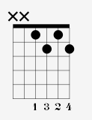
The most common voicing for the diminished chord is as shown. The notes of this chord are (from bottom to top, i.e. 4th string to 1st string) d# (or eb), a, c, and f# (or gb). Because of the symmetry of this scale, you can move the chord up 3 frets and still get all the same notes.

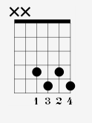
Here the notes are f#, c, eb, and a. These are the same notes as above, just in a different order. Try recording the first voicing (or have a friend play it) and then playing the second one over it at the same time. You will see that it just sounds like one big diminished chord.

This is a great thing because it means that one single voicing can serve as 4 chords. It can be A^{o7}, C^{o7}, Eb^{o7}, or F#^{o7}. And going further, it means that if you played this chord starting at the first fret, then the 2nd fret, then the 3rd fret, you would have played all the diminished 7th chords that exist! Why? Because when you got to the 4th fret it would be a repeat of the one at the 1st fret as shown earlier.
My suggestion is to think of it as 3 families. Each family has 4 members and they can all substitute for each other when one doesn’t feel like going into work (lol). The 3 families are:

C – Eb – Gb – A | F – Ab – B – D | G – Bb – Db – E

If you memorize these families then you can quickly know which one of the 3 chords we mentioned above will fit the chord being asked for in the sheet music you may be reading. As long as the chord contains the root of the chord somewhere in it, it will be a match. For example, if you saw F# ^{o7} you could play the first voicing above because the f# is in the chord (at the 1st string in this case).

All that being said, it’s also very easy to learn 2 simple diminished voicings that equate to 6th-string and 5th-string barre chords. They look like this:
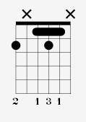
This could be called any of 4 names, but for practical purposes of associating the lowest note as the root, we will call it F#^{o7}.

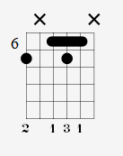
Similarly, let’s call this one B^{o7}.

As for diminished chords whose roots are on the 5th-string, here is B^{o7} and F# ^{o7}, respectively.

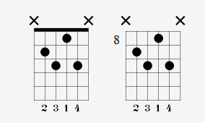

Rock/ Pop Songs That Use Diminished Chords
Blue Jay Way – Beatles; D.A.N.C.E. – Justice; Empire of the Sun - Delta Bay; Every Time You Go Away - Paul Young; Friends in Low Places - Garth Brooks; How to Fight Loneliness – Wilco; Let There Be Light – Justice; Libertango – Piazzolla; Michelle – Beatles; My Sweet Lord - George Harrison; Pleasure – Justice; Road Trippin - Red Hot Chili Peppers; Single Ladies – Beyonce; Song for the Asking - Paul Simon; Strawberry Fields Forever – Beatles; Twin Skeletons - Fall Out Boy; Valentine - Justice

As you can see there are many reasons to learn the diminished chord. Use them to play existing music or try writing chord progressions with it. In another article we will talk about the theoretical functions of the diminished chord. Until then, have fun and good luck.

About the Author: Dennis Winge is a pro guitarist and educator living in the Finger Lakes Region of New York State. For guitar lessons in Ithaca, NY be sure to check out his school.

